Session

🗂️ What Are Session in Web Development?
# Source: AI Source: Provided by: [Data Path: Persons Table -> ID Column: 1, Name_En Column: Motasem Essam] -> From: [ChatGPT] on [2/12/2026]
A session is a way to store information (like user login, cart items, or preferences) on the server during a user’s visit to a website — so the server can remember "who you are" across different pages.

✅ Simple Definition:
# Source: AI Source: Provided by: [Data Path: Persons Table -> ID Column: 1, Name_En Column: Motasem Essam] -> From: [ChatGPT] on [2/12/2026]
A session is a short-lived, server-side memory space tied to a single user — used to preserve data between requests.

🧠 Real-Life Analogy:
# Source: AI Source: Provided by: [Data Path: Persons Table -> ID Column: 1, Name_En Column: Motasem Essam] -> From: [ChatGPT] on [2/12/2026]
Think of a session like a temporary locker at a gym:
- You get a key (session ID) when you arrive
- You put your stuff (user data) inside
- The locker is yours until you leave (expire)

🔁 How Sessions Work
# Source: AI Source: Provided by: [Data Path: Persons Table -> ID Column: 1, Name_En Column: Motasem Essam] -> From: [ChatGPT] on [2/12/2026]
- 👤 You visit a website — the server starts a session
- 🔑 Server generates a Session ID
- 🍪 Session ID is stored in your browser’s cookies
- 🔄 On every request, the cookie is sent back to the server
- 📦 Server retrieves your session data using the ID

🧾 Example in PHP:
# Source: AI Source: Provided by: [Data Path: Persons Table -> ID Column: 1, Name_En Column: Motasem Essam] -> From: [ChatGPT] on [2/12/2026]
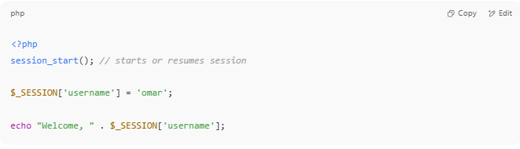

<?php
session_start(); // starts or resumes session

$_SESSION['username'] = 'omar';

echo "Welcome, " . $_SESSION['username'];

🧠 What You Can Store in Sessions
# Source: AI Source: Provided by: [Data Path: Persons Table -> ID Column: 1, Name_En Column: Motasem Essam] -> From: [ChatGPT] on [2/12/2026]
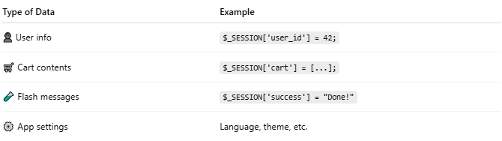

Type of Data | Example
👤 User info | $_SESSION['user_id'] = 42;
🛒 Cart contents | $_SESSION['cart'] = [...];
🧪 Flash messages | $_SESSION['success'] = "Done!"
⚙️ App settings | Language, theme, etc.

📍 Where Is Session Data Stored?
# Source: AI Source: Provided by: [Data Path: Persons Table -> ID Column: 1, Name_En Column: Motasem Essam] -> From: [ChatGPT] on [2/12/2026]
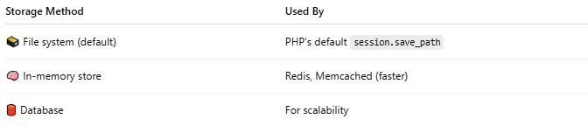

Storage Method | Used By
🗃️ File system (default) | PHP's default session.save_path
🧠 In-memory store | Redis, Memcached (faster)
🛢 Database | For scalability

⌛ Session Lifetime
# Source: AI Source: Provided by: [Data Path: Persons Table -> ID Column: 1, Name_En Column: Motasem Essam] -> From: [ChatGPT] on [2/12/2026]
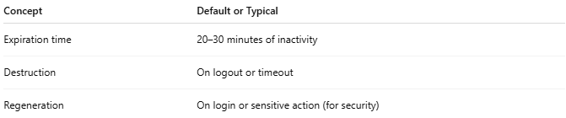

Concept | Default or Typical
Expiration time | 20–30 minutes of inactivity
Destruction | On logout or timeout
Regeneration | On login or sensitive action (for security)

🛡️ Session Security Tips
# Source: AI Source: Provided by: [Data Path: Persons Table -> ID Column: 1, Name_En Column: Motasem Essam] -> From: [ChatGPT] on [2/12/2026]
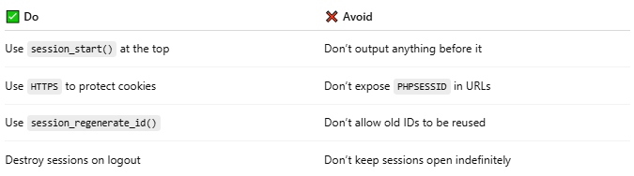

✅ Do | ❌ Avoid
Use session_start() at the top | Don’t output anything before it
Use HTTPS to protect cookies | Don’t expose PHPSESSID in URLs
Use session_regenerate_id() | Don’t allow old IDs to be reused
Destroy sessions on logout | Don’t keep sessions open indefinitely

🆚 Session vs Cookie vs Token
# Source: AI Source: Provided by: [Data Path: Persons Table -> ID Column: 1, Name_En Column: Motasem Essam] -> From: [ChatGPT] on [2/12/2026]
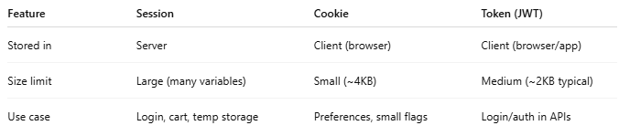

Feature | Session | Cookie | Token (JWT)
Stored in | Server | Client (browser) | Client (browser/app)
Size limit | Large (many variables) | Small (~4KB) | Medium (~2KB typical)
Use case | Login, cart, temp storage | Preferences, small flags | Login/auth in APIs

